Dear Philip Rowe,
Howdy. Last year I made a simple 2D image convolution module for the DE-115 FPGA development board as a solution to an assignment for MTRX3700, a course I tutored. I am currently reworking the course and hope to use this module to create a (super basic) convolutional neural network implementation in hardware. It will probably become extension reading for interested students, however good to have on one’s GitHub portfolio!

I have made the following GitHub repository with the existing module:
https://github.com/lewisMW/FPGA-CNN

If you have some time, it would be great to have you contribute! Here are some suggested tasks:
- Background Reading The convolution question from the course last semester is presented on the pages following. First read this for background (Hints and Tricks is not so relevant). Then read the existing solution Verilog code on the repository. It is well commented.
- Designing the Architecture Convolution is only one of the steps in CNNs. We need to design an architecture to that will process convolutions, activation functions, pooling, fully connected layers, and the pipelines in between (FIFOs) - not to forget memory and IO. We have somewhat limited logic cells (114’480 LEs), DSP resources and on-chip memory (3’888 kbit) on the DE2-115, although for now assume that we can use the full 128MB available in the SDRAM. Therefore, it is probably best to process one convolution layer at a time – and the layer sizes will have an unimpressive upper bound, which is perfectly fine for educational purposes! There should be plenty of material online regarding FPGA CNNs online, such as this article on a CNN accelerator. This is very open-ended! I was planning to avoid researching too much in order to have a bit of fun in designing.
- Coding After considering some basic architecture, you can start coding a module or two! I recommend modularising as much as possible in order to test each submodule without the need for the FPGA at hand. Example modules from the paper linked above: Controller, DataMover, InBuffer, OutBuffer, ConvolutionUnit. We could definitely do better modularisation than that.
- Testbench/Verification As this is also a resume project, I would like to flex some SystemVerilog (SV) skills. SV is an extension to Verilog with many good features, especially for simulation. Additionally, it introduces object oriented programming to Verilog, similar to what C++ is to C. To impress, read this SV testbench guide and create a fully-fledged SV testbench for a given (simple) submodule! Try integrating exciting SV features into the testbench, such as randomisation and constraints, functional coverage and SystemVerilog Assertions.

To test the Verilog/SystemVerilog, it is best to just copy the code into EDA Playground and run it there. The convolution code has a RAM module that requires Quartus/ModelSim to test it. I have a testbench if you are interested. Just test your own (simpler) submodules for now.

Q3. Filtering Images with a FPGA [5 marks]
d). Implement a convolution filter, using the kernels supplied in the template code ‘filter.v’. Change kernel using the switches. See https://en.wikipedia.org/wiki/Kernel_(image_processing). This task will require processing multiple pixels in both x and y directions at a time. [4 marks] [Code] [Demo]

The kernels (aka. convolution matrix) supplied in the template code are:
/*
* Kernels (For Q3 d).) See https://en.wikipedia.org/wiki/Kernel_(image_processing)
*
* Sharpen:
* | 0 -1 0|
* |-1 5 -1|
* | 0 -1 0|
*
* Gaussian Blur:
* 1 |1 2 1|
* — |2 4 2|
* 16 |1 2 1|
*
* Ridge Detection:
* |-1 -1 -1|
* |-1 8 -1|
* |-1 -1 -1|
*/

Kernels: Convolution in Image Processing
An image can be viewed as a matrix of pixels. In a convolutional filter, a kernel is then a matrix that is convolved over the image matrix, which can achieve effects such as blurring, sharpening, edge detection and more. Other than image filtering, this scheme is used in convolutional neural networks (CNN) - the work you do for this question could be extended to provide a FPGA hardware-based acceleration for deep learning!

The process of convolving a 3x3 kernel matrix with the image matrix is illustrated in the following animation: 2D Convolution Animation - Kernel (image processing) - Wikipedia. In short, the values of the matrix are multiplied elementwise with a 3x3 submatrix of the source image matrix, and then summated together. In the output matrix, the element corresponding to the center element of the submatrix is set to this sum:
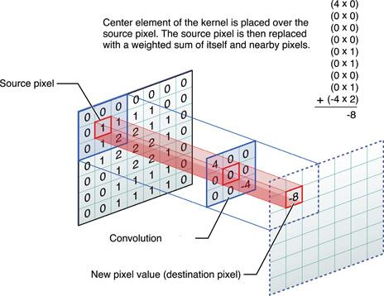

Implementing 2D Convolution in Hardware
The following scheme can be used to implement 3x3 2D convolution in hardware:
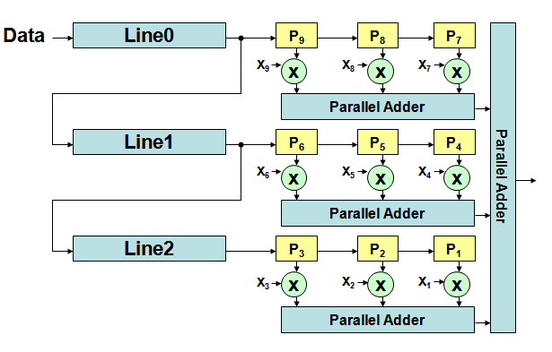
- Data
  - A single pixel of the source image.
  - 24-bits of data for a single RGB pixel (8-bits per colour).
  - input [23:0] data_in.
- Line0, Line1, Line3:
  - 3 line buffers.
  - These are basically like shift registers that have a length of the image width. E.g. for a 640x480 resolution image, the line buffers would have depth 640 (so 640 24-bit registers connected in series).
  - We have three of these to ensure that the pixel data entering registers P9, P6 and P3 are exactly 640 pixels apart - i.e. they are pixels vertically adjacent to each other in the image.
  - Remember how we implemented a shift register in a previous module?! You can try modifying and instantiating this.
- P1,P2, ..., P9:
  - 3x3 = 9 clocked pixel registers that temporarily store the source submatrix pixels currently being multiplied with the kernel at a given clock cycle. The outputs of these registers are multiplied with the kernel matrix elements x1,x2, ..., x9.
- x1,x2, ..., x9:
  - The kernel matrix entries to be multiplied with the pixels stored in P1,P2, ..., P9. Multiplication can be implemented with the multiplication operator ‘*’ (Quartus can synthesise this!).
- Parallel Adders:
  - These add their input signals together. Can be implemented in Verilog simply using the addition operator ‘+’.
- Output
  - A single pixel of the output image.
  - The output is then the sum P9*x9+P8*x8+...+P1*x1. This can then be written into a separate ram block module, storing the entire output image.
  - output [23:0] out.

Note that this design will require clock cycles to initially fill the 3 line buffers and 3 pixel registers! After this, the output pixel stream will be a fixed offset (calculate this) behind the input data pixel stream. You must account for this offset in relation to the VGA output signal.

Hints and Tricks:

You may change the input & output ports and any module or file in the template.

The timing for this part is non-trivial. Consider how many clock cycles your buffers take to produce an output. Does multiplying/dividing take extra cycles? (Are these even synthesizable?) How will you ensure: a) the filtered data fits into the VGA displaying periods;b) the input data is ignored during VGA blanking intervals? Hint: VGA_BLANK_N
- You can use an extra on-chip RAM to store the result of your convolutions. To do this, use the “IP Catalog -> RAM: 2 Port” . Think about how many 24-bit words you will need to store an image of size 640x480. We opt for 2-port RAM so that we can write and read separately at the same time (the write and read addresses can be different values).
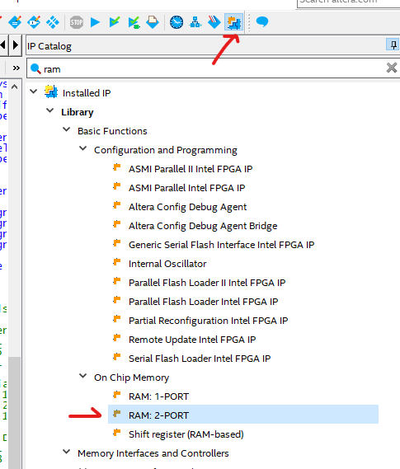
- See the assignment Canvas page for a video on how to create the 2-port RAM IP.
- Another non-trivial consideration that must be accounted for is the upscaling implemented in ‘vga_controller.v’ (see the commented lines 41 to 80 in this file). Because our FPGA does not have enough dedicated RAM blocks to store 2 640x480 images, the template code instead stores the images at half-resolution: 320x240. This is then ‘upscaled’ by simply repeating each pixel horizontally and vertically (so each pixel becomes a square of 4 pixels after upscaling). This means that your 3x3 filter is processing identical pixels (and so will not be as effective). Can you figure out a way to add a ‘step’ of 2 pixels in both the horizontal and vertical directions for the pixels multiplied by the kernel?
  - Note that the template code uses ‘vga_addr’ to store the row-major index of the 320x240 image and maps it to the 640x480 upscaled image. The 640x480 upscaled RGB datastream is inputted into the filter.
- Another consideration is what to do with the edges of the output image. For instance, the top-left corner of the output image would be based on the 8 pixels surrounding it from the source image, however, the 5 pixels to the left and above it are out of bounds. You may choose to simply assume such out-of-bounds pixels are black (0,0,0).
- Be careful - just as in Q3.b, you may need to consider overflows and signed versus unsigned bit vectors. You can use the Verilog ‘integer’ data type for arithmetic operations, then convert this back to an appropriate unsigned 8-bit pixel colour value. Avoid floating point numbers altogether.
- It is recommended that you use the provided testbench for simulating Q3, to allow for closer inspection and debugging of your design. See Q3 Testbench Guide.
  - If you have edited Q3.v, such as adding in new signals or connections between modules, you will need to also make these changes in the filter_TB.v.
  - It will take a few minutes to run this simulation for the convolution calculations.
  - This testbench takes a ‘snapshot’ of the most recent VGA output from a time delay set by ‘filter_TB.v’ lines 67 to 69. You should change this time delay to:
    - 1). Make sure you are capturing the full output image, and
    - 2). Check that the image is stable and not changing over time.
  - You should then dedicate some time to test this on the FPGA board, to verify you still do not have timing problems and the VGA output image is stable.
- To simplify timing issues slightly: the convolution operation only needs to be applied to the entire image once.
- Using a greyscale image as the source image produces better results aesthetically for the sharpening and ridge detection kernels. To do this, change line 12 in the ImgToMIF.m MATLAB script to: colours = gray(num_colours);
- Here is a great interactive resource to learn more about convolutional filters and to compare with your results: Image Kernels explained visually (setosa.io).
- Reminder: the DLY_RST reset signal is active low! Make sure you check if your reset signal is active high or active low in both filter_TB.v and Q3.v.

